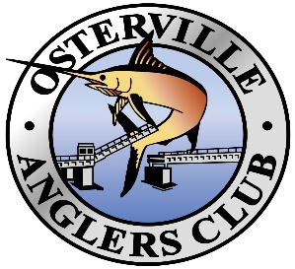

OAC Tournament Schedule – 2020
May 21st (Th) Season Opening Captains Meeting with MA Fishing Regulations overview
May 22nd (Fri) Striper Night - at the CYY docks
May 22nd (Fri) OAC Derby Begins
May 23rd (Sat) Larry Coggeshall – Black Sea Bass Only – (S) Fishing Hours 0600 – 1000
May 24th (Sun) Three Bays Spin/Fly Catch & Release – Fishing Hours 0600 - 1000
June 13th (Sat) OAC1000 (S)
June 21st (Sun) Father’s Day Tournament (S) Fishing Hours 0500 - 1400
June 25th (Th) Barnstable Youth Hockey (S) (hosted by Baxter’s Boat House)
July 11th (Sat) Game of Shoals
July 18th (Sat) Ladies Shoal Troll (S) (to benefit Making Strides against Breast Cancer)
August 1st (Sat) OAC Fluke Tournament – Inshore & Offshore Divisions
September 12th /13th (Sat/Sun) OAC Open Derby (False Albacore, Bonito, Spanish mackerel, Bluefin Tuna…..)
September 26th (Sat) Sellars One Day Bass (S)
October 17th (Sat) OAC Derby Ends
(S) Sellars Eligible Tournament Total = 7
Note the following:
Fishing Hours are 0600 – 1400 unless otherwise indicated
Three Bays Catch & Release – format is being reviewed
New for 2020:
Larry Coggeshall tourney – Black Sea Bass only, limited fishing boundaries have been removed and standard OAC boundaries will be used.
A Women’s division has been added for all tournaments
Black Sea Bass will be added to all tournaments (1st, 2nd & 3rd places), eligible for OAC Annual Award but not for Sellars points

